 

# Madhuben & Bhanubhai Patel Institute of Technology

**(A Constituent College of CVM University) New V. V. Nagar**

**COMPUTER ENGINEERING DEPARTMENT**

**Mini Project Proposal on**

***Online eBook Store Website***

**Submitted By**

**Name of Student : Nikita Dudhregiya**

**Enrolment Number : 12202040703024**

**Name of Student : Jagruti Parmar**

**Enrolment Number: 12202040703014**

**MINI PROJECT (102040601)**

**A.Y. 2023-24 EVEN TERM**

1. **Introduction**

**1.1 Problem Statement:**

On successfully login in to the online eBook store website, the customer can purchase a wide range of books. The customer will pick their favorite books from the online bookstore sites. They do not need to go to physical shops, instead need a computer and payment-making options like net banking, credit cards, or debit cards. If an order has not yet been shipped to the customer, the customer may cancel it. The payments will be credited to the customer's debit or credit card, depending on their preference.

* 1. **Project Overview**:

Creating an online eBook store website is a substantial project that involves various components, including frontend development, backend development, database management, and potentially payment integration.

1. Homepage:

* Featured eBooks.
* Special promotions or discounts.

1. Product Pages:

* Cover image, title, author, and description.
* Price and discount information.
* "Buy Now" or "Add to Cart" button.
* Customer reviews and ratings.

1. Shopping Cart:

* View and manage items in the cart.
* Adjust quantity, remove items.
* Proceed to checkout.

1. Checkout Process:

* Shipping information.
* Payment methods (credit card, debit card, etc.).

1. Database Management:

* Store book information (title, author, description, price, etc.)
* User data (registration info, order history, etc.)

6. Admin panel:

* Backend interface for managing products, users, and orders.
  1. **Aim and Objective**:

The main aim is to design a bookstore where customers can visit our site any time of the day from anywhere to view the available books, choose any of them, and order by paying online or opt for cash on delivery. The administrator will regularly add any new books available to them for sale. The administrator will take books from reputed publishers and vendors only. The main objective of an online eBook store project is to create a digital platform that provides users with a seamless and enjoyable experience for allowing customers to buy books online.

1. **System Analysis:**
   1. **Motivation:**

The motivation behind developing an online eBook store website lies in addressing the evolving reading habits and preferences of modern consumers. With the increasing digitalization of content, readers seek convenient and immediate access to a wide range of books. The online eBook store aims to provide a centralized platform for book enthusiasts to explore books details, purchase, and enjoy digital literature.

* 1. **Brief Literature Survey**:

2.2.1 Different Methods for Building Online eBook Stores:

* Traditional eCommerce Platforms: Some websites utilize popular eCommerce platforms (e.g., Amazon eBooks, Shopify) with extensions or plugins tailored for selling digital products like eBooks. These platforms often provide a user-friendly interface but may lack customization options.
* Custom Web Development: Building a custom solution using HTML, CSS, JavaScript, PHP, and SQL allows for full control over features and design. This approach suits tailored and scalable solutions but requires more development effort.

2.2.2 Comparison of Different Methods:

* Traditional eCommerce platforms are generally easier to set up and manage, requiring less technical expertise. Custom development provides the flexibility to design a user interface tailored to specific needs but may require more development time.
* Custom development allows for the complete ensuring a unique and branded user experience. eCommerce platforms may have limitations in terms of design and feature customization.
* Custom solutions can be more easily scaled to accommodate growing user bases and expanding book catalogs.

1. **Design: analysis, design methodology, and implementation strategy**
   1. **Design Analysis:**

1. Analysis of Requirements:

* Identify and understand the key requirements for the online eBook store website, considering both user and administrative needs.
* Gather user reviews to define functionalities and features.

2. Functional and Non-functional Requirements:

* Define functional requirements, including user authentication, book catalog management, shopping cart, checkout, and user profiles.
* Specify non-functional requirements, such as security, scalability, and performance.

3. Data Modeling:

* Create a database schema to represent entities like books, users, orders, and reviews.
* Define relationships between entities and establish data integrity constraints.

4. User Interface Design:

* Develop wireframes and mockups to visualize the website's user interface.
* Ensure a responsive design for seamless user experiences across various devices.
  1. **Design Methodology:**

1. Waterfall Model:

* Adopt a Waterfall model to Proceed through phases like requirements, design, implementation, testing, and maintenance in a linear fashion.

2. Agile Development:

* Divide the project into sprints, allowing incremental development and continuous feedback from users.

**3.3 Hardware Requirements:**

1. Web Server:

* A dedicated or cloud-based server for hosting the website.

1. Database Server:

* A server for hosting the MySQL database.

1. Storage:

* Adequate storage for hosting eBook files, images, and other media.
  1. **Software Requirements:**

1. Operating System:

* Windows-based operating system for servers.

1. Database Management System (DBMS):

* MySQL for storing and managing application data.

1. Server-Side Scripting Language:

* PHP for server-side logic.

1. Frontend Technologies:

* HTML, CSS, and JavaScript for building the user interface.

1. Database Management Tool

* phpMyAdmin for managing MySQL databases.
  1. **User Interface Design:**

One of the most important factors in determining an application's user-friendliness is its user interface. Because it is the component with which the user interacts.

1. Register and Login Interface:



Login page

  
 Create Account page

1. **Implementation**

The implementation phase entails the development of an executable program based on the design created during the design phase. Selecting programming languages, additional tools, and technologies like frameworks, selecting hardware platforms, and coding the system are some of the main activities carried out during this phase.

* 1. **System Flow:**

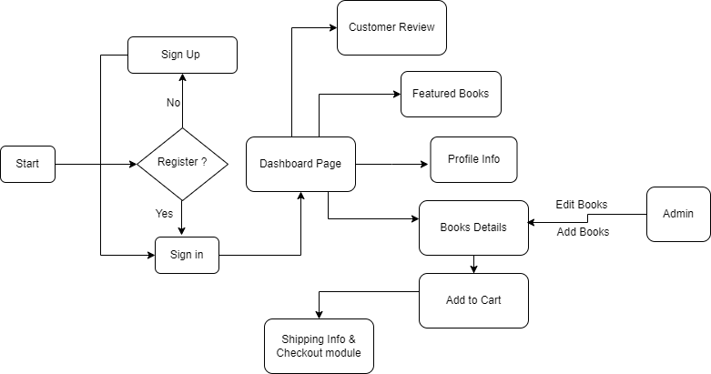

* 1. **Module Specification:**

1. Registration Module:

Specification:

* Collect user details (name, email, password).
* Validate and store user information in the database.

2. Catalog Browsing Module:

Specification:

* Retrieve and display a list of available eBooks.
* Allow users to features books.

3. eBook Details Module:

Specification:

* Display detailed information about a selected eBook.
* Show reviews and ratings.

4. Shopping Cart Module:

Specification:

* Allow users to add or remove items from the shopping cart.
* Calculate and display the total price.

5. Checkout Module:

Specification:

* Collect shipping details from the user.
* Process payment using a secure gateway.

6. User Profile Module:

Specification:

* Allow users to view and edit their profiles.
* Implement profile picture upload functionality.
  1. **Timeline Chart:**

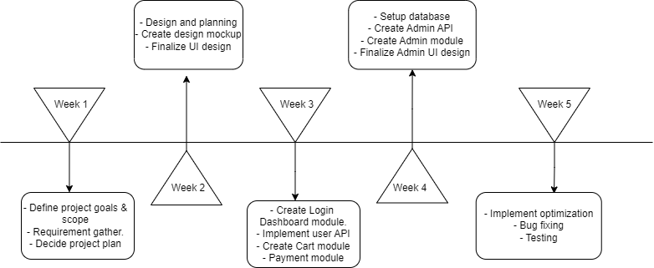

1. **Conclusion:**

In conclusion, the development of an online eBook store website presents an opportunity by combining user-friendly interfaces, secure transactions, and a diverse catalog of eBooks, the platform aims to provide a seamless and enjoyable experience. The implementation plan, registration, catalog browsing, shopping cart management, and user profiles, follow a systematic approach to ensure the successful creation and deployment of a robust online eBook store.

1. **References:**
   * + - <https://www.w3schools.com>
       - <https://www.tutorialspoint.com>
       - <https://stackoverflow.com>
       - <https://www.javatpoint.com/reactjs-tutorial>